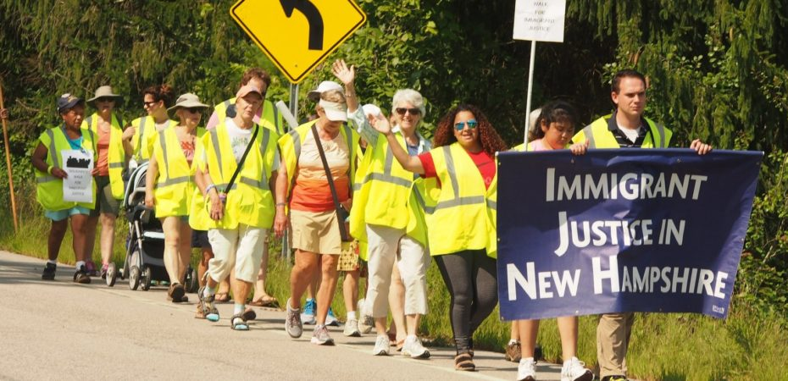
SOLIDARITY WALK FOR IMMIGRANT JUSTICE
Wednesday, August 21 through Saturday, August 24
Participants will walk the 40 miles from Concord to Dover over the course of these days and you are welcome to join us! The walk begins in Concord at the US District Courthouse. The walk will end at the Strafford County Jail in Dover, where ICE jails people slated for their deportation. As we walk, we will hold educational, prayerful and discussion-focused evening events open to the public.
Itinerary Outline
- Wednesday, August 21: Concord to Chichester (9 miles)
- Thursday, August 22: Chichester to Northwood (11 miles)
- Friday, August 23: Northwood to Lee (12 miles)
- Saturday, August 24: Lee to Dover (9 miles)
Fundraising
You can make a donation to New Hampshire bond funds that provide money so that people held by ICE for alleged immigration violations can get out of the jail and continue life in the community while awaiting their day in court.
For more details, to sign up or to donate, please see the NH Council of Churches website:
http://www.nhchurches.org/walk2019
More questions? Call Granite State Organizing Project:
(603) 668-8250
SOLIDARITY WALK FOR IMMIGRANT JUSTICE
Wednesday, August 21 through Saturday, August 24
Participants will walk the 40 miles from Concord to Dover over the course of these days and you are welcome to join us! The walk begins in Concord at the US District Courthouse. The walk will end at the Strafford County Jail in Dover, where ICE jails people slated for their deportation. As we walk, we will hold educational, prayerful and discussion-focused evening events open to the public.
Itinerary Outline
- Wednesday, August 21: Concord to Chichester (9 miles)
- Thursday, August 22: Chichester to Northwood (11 miles)
- Friday, August 23: Northwood to Lee (12 miles)
- Saturday, August 24: Lee to Dover (9 miles)
Fundraising
You can make a donation to New Hampshire bond funds that provide money so that people held by ICE for alleged immigration violations can get out of the jail and continue life in the community while awaiting their day in court.
For more details, to sign up or to donate, please see the NH Council of Churches website:
http://www.nhchurches.org/walk2019
More questions? Call Granite State Organizing Project:
(603) 668-8250

